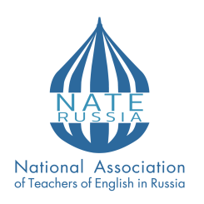

NATIONAL ASSOCIATION OF TEACHERS OF ENGLISH IN RUSSIA
XXIX NATE-Russia Conference
“NATE-Russia: Further and Beyond”
Nizhny Novgorod
(MIND THE VENUE IS CHANGED)
22 – 24 April 2024
Dear colleagues,
The National Association of Teachers of English (NATE-Russia) is pleased to invite you to the XXIX Conference «NATE-Russia: Further and Beyond».
The Conference is a comprehensive gathering of education professionals and scholars, featuring the field’s leading conference program, an extensive lineup of presentations showcasing the most cutting-edge findings and theories, and a variety of valuable networking opportunities. «NATE-Russia: Further and Beyond» conference will be held on 22 - 24 of April 2024 in Nizhny Novgorod.
NATE-Russia Conference is the main event for educating and training professionals to discuss issues, research, development, strategies, and new technologies, and most importantly, identify solutions to meet new challenges of English language education.
Nizhny Novgorod, Hotel Volna, Lenin prospect, 98
Dates: April 22-24, 2024.
Format: mixed (in-person and online).
Working languages: English, Russian.
The conference topics include the following:
1. Professional Development for Language Teachers: Current Trends and Future Directions;
2. Exploring New Horizons in Linguistics Research in English Language Studies;
3. Inclusion and Diversity in English Language Learning;
4. The Future of English Language Teaching in the Digital Age;
5. Teaching Gifted Learners;
6. Innovative Approaches in Teaching Young Learners and Teenagers;
7. Integrating CLIL, EMI, ESP, EAP: from Theory to Practice;
8. Best Practices in Life-long Learning;
9. Assessment and Evaluation in English Language Teaching;
10. Wellbeing in Teaching and Learning.
Presentation time limit:
Panel Discussion – 40 min.
Workshops – 40 min.
Plenary talks – 20 min.
SIG PRESENTATIONS– 10 min.
All participants will receive official certificates of participation.
Deadlines:
Speakers Registration and Payment – March 31, 2024;
Attendees Registration and Payment – April 20, 2024;
Participation Fees:
NATE members (offline) – 900 RUB;
NATE members (online) – 600 RUB;
Non-NATE members (offline) – 1800 RUB;
Non-NATE members (online) – 1200 RUB;
Students NATE members – 400 RUB;
Students Non-NATE members – 600 RUB.

Follow the link to pay the fee:
https://joinnate.ru/
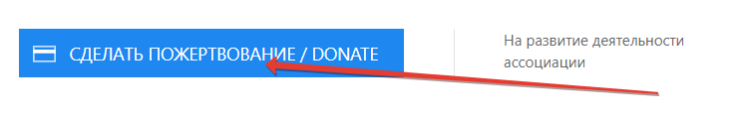
Mind to write your full name in the donation form!

To register go to: https://forms.yandex.ru/cloud/65caf46290fa7bce6b5a8c0c/
Contacts:
Email: secretarynate@gmail.com, Julia Starovoytova
svetlana_chspu@mail.ru Svetlana Sannikova

